kubernetes task 02
- Create a simple pod using yaml task: write a yaml file to create a pod named firstpod with an nginx container. Verify the pod creation using kubectl get pods and check the logs of the container using kubectl logs firstpod.
TO create pod using yaml file:
kubectl create -f <file_name>.yml --dry-run --> to check the output
kubectl create -f <file_name>.yml

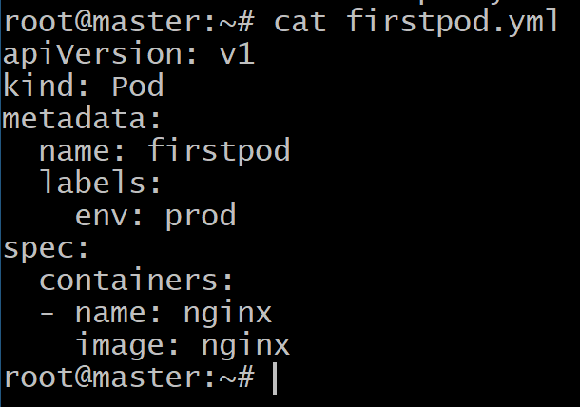
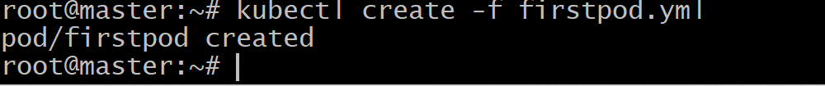
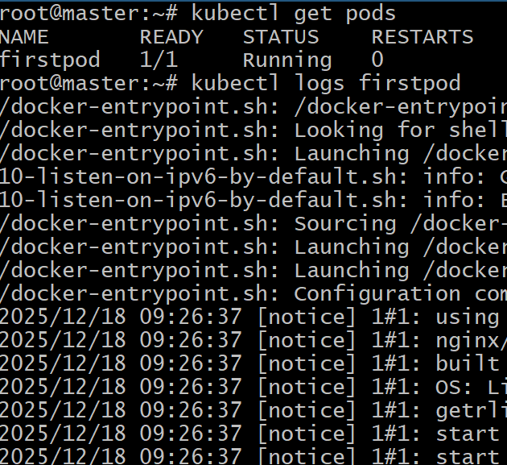
- Set environment variables in a pod task: modify the yaml file to include environment variables myname: sabair and city: hyderabad. Deploy the pod and use kubectl exec <pod_name> -- env to check if the environment variables are set properly.
Set Env Variables inside container Pods:
apiVersion: v1
kind: Pod
metadata:
name: firstpod
labels:
env: prod
name: sabair
spec:
containers:
- name: nginx
image: nginx
env:
- name: myname
value: sabair
- name: City
value: Hyderabad
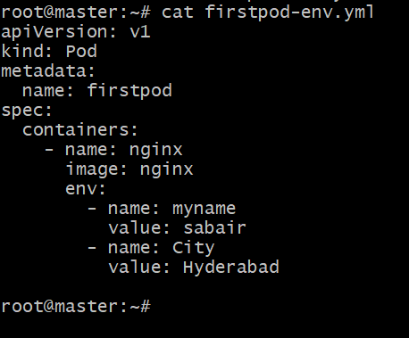
kubectl apply -f firstpod-env.yml
kubectl exec firstpod -- env
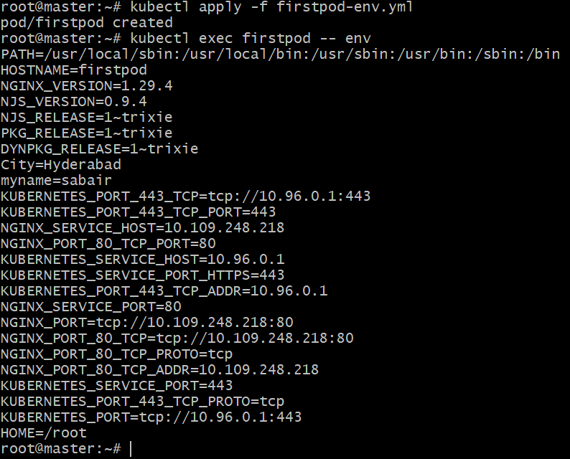

- Deploy a pod with commands (args) in yaml task: modify the yaml file to add args that instruct the container to sleep for 50 seconds. Deploy the pod and use kubectl describe pod to verify the args are correctly passed to the container.
Vi firstpod-args.yml
apiVersion: v1
kind: Pod
metadata:
name: firstpod
spec:
containers:
- name: nginx
image: nginx
args:
- sleep
- "50"
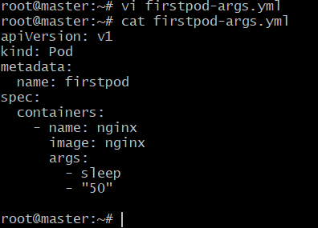
kubectl apply -f firstpod-args.yml
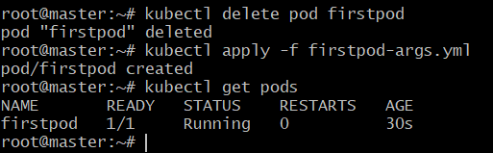
Kubectl describe pod firstpod
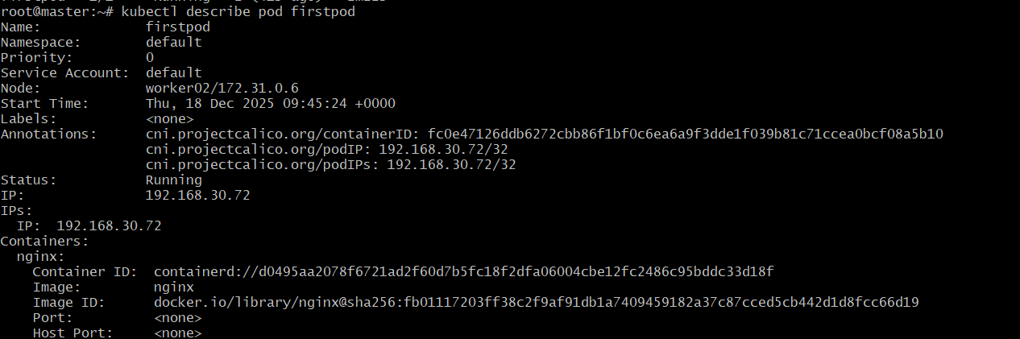
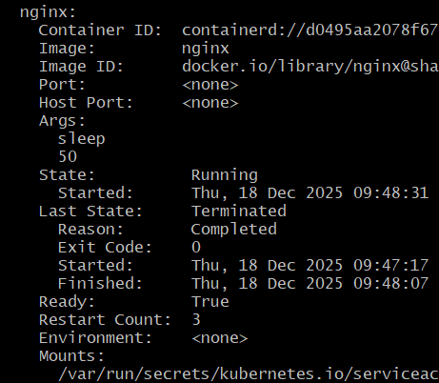
- Create a pod with two containers task: create a yaml file to define a pod with two nginx containers inside. Use kubectl exec to access both containers and verify that both containers can communicate through the same network (e.g., using telnet between them).
Create a Pod with Two Containers
YAML: `two-containers.yml`
```yaml
apiVersion: v1
kind: Pod
metadata:
name: twonginx
spec:
containers:
- name: nginx1
image: nginx
- name: nginx2
image: nginx

kubectl apply -f two-conatiners.yml
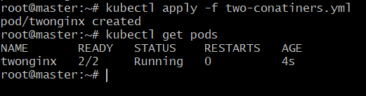
kubectl exec -it twonginx -c nginx1 – bash
kubectl exec -it twonginx -c nginx2 – bash
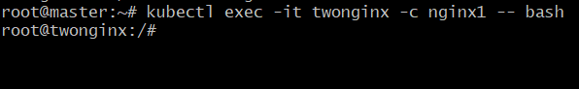
In nginx1
apt update
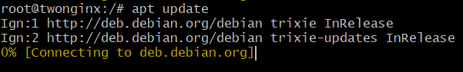
apt install -y curl
curl local host
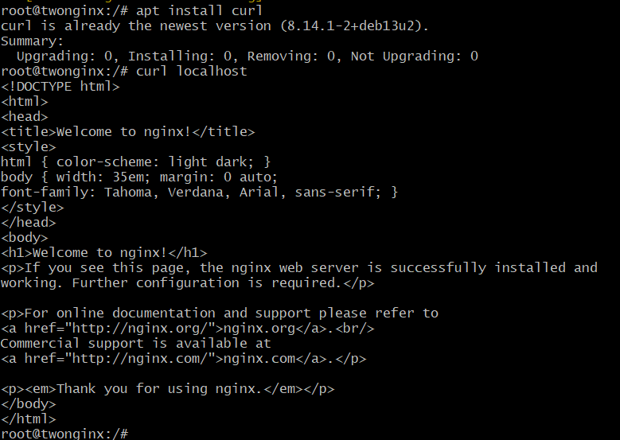

- Set up an init container in a pod task: modify the yaml to include an init container that sleeps for 30 seconds before the main containers start. Verify the init container's execution using kubectl describe pod and check the logs to confirm its completion.
Vi init.yaml
apiVersion: v1
kind: Pod
metadata:
name: initpod
spec:
initContainers:
- name: init-sleep
image: busybox
command: ["sh", "-c", "sleep 30"]

containers:
- name: nginx
image: nginx
kubectl apply -f init.yaml
kubectl describe pod initpod
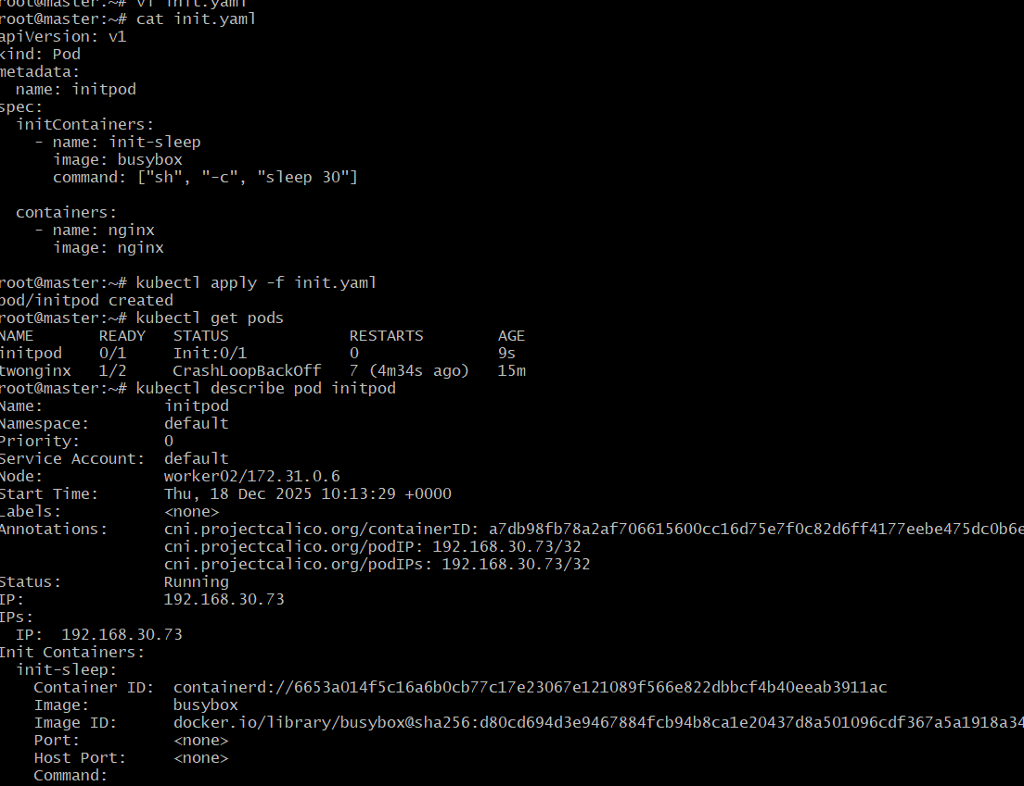

kubectl logs initpod -c init-sleep

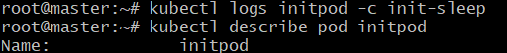

- Run a dry run command to generate yaml task: use the kubectl run nginx --image=nginx --dry-run=client -o yaml command to generate a pod yaml definition. Modify the generated yaml to suit specific requirements (e.g., labels or environment variables) and deploy it.
kubectl run nginx --image=nginx --dry-run=client -o yaml > dryrun-pod.yml
apiVersion: v1
kind: Pod
metadata:
name: nginx
labels:
run: nginx
spec:
containers:
- name: nginx
image: nginx
resources: {}
dnsPolicy: ClusterFirst
restartPolicy: Always
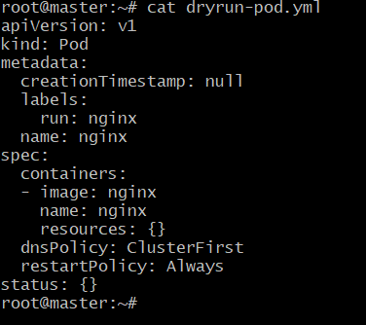

Kubectl apply -f dryrun.yml
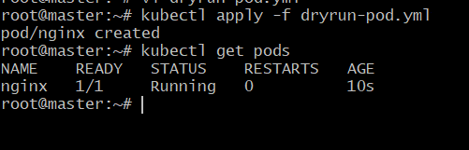

- Use kubectl apply vs kubectl create task: create a yaml file to define a pod. First, deploy it using kubectl create -f <file_name>.yml and then modify the yaml (e.g., change the image version). Use kubectl apply to redeploy and verify the difference between both commands.
kubectl create vs kubectl apply
YAML: `apply-vs-create.yml`

apiVersion: v1
kind: Pod
metadata:
name: applypod
spec:
containers:
- name: nginx
image: nginx:1.25
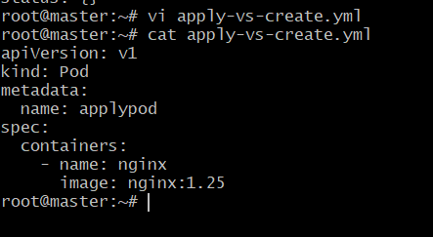
kubectl create -f apply-vs-create.yml
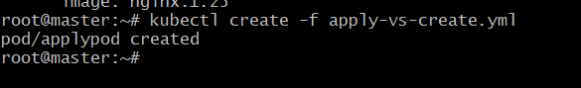
Modify Image
```yaml
image: nginx:latest
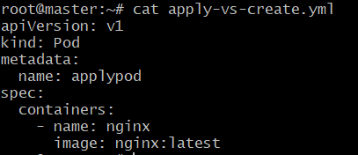

kubectl apply -f apply-vs-create.yml
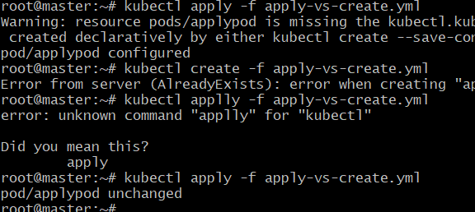

- Edit an existing pod configuration task: use kubectl edit pod <pod_name> to modify the running pod's environment variables or image. After making the changes, verify if they took effect by checking the container logs or environment variables using kubectl exec.
kubectl edit pod applypod
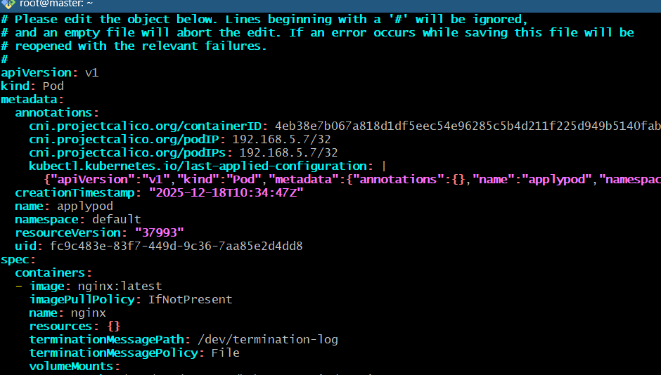
Modify:
yaml
image: nginx:alpine
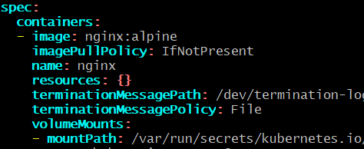
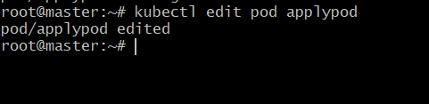
Kubectl describe pod applypod
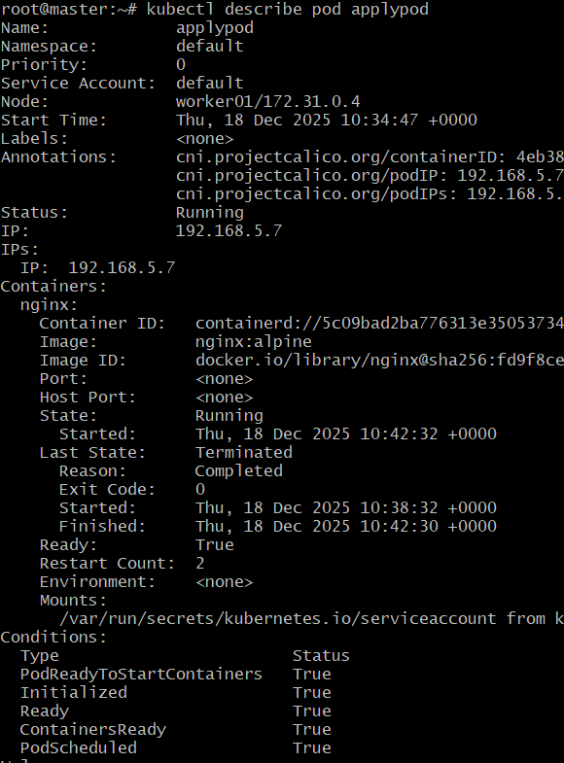

- Expose a pod using a service task: create a yaml file to expose your firstpod using a service (clusterip). Ensure that your service is exposing the pod on port 80 and verify it using kubectl get svc.
Vi firstpod-service.yml
apiVersion: v1
kind: Service
metadata:
name: firstpod-service
spec:
type: ClusterIP
selector:
app: nginx
ports:
- port: 80
targetPort: 80
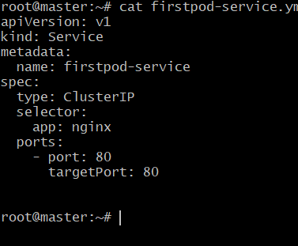
Kubectl apply -f firstpod-service.yml
kubectl get svc
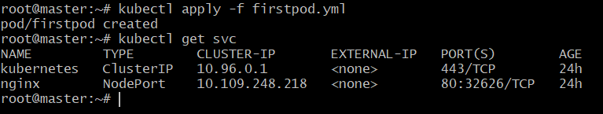

- Pod with resource limits and requests task: add resource requests and limits to the containers in your yaml file. Specify cpu and memory requests/limits for both containers and deploy the pod. Use kubectl describe pod to verify if the resource configurations are correctly applied.
YAML: ‘vi resources-pod.yml`
apiVersion: v1
kind: Pod
metadata:
name: resourcepod
spec:
containers:
- name: nginx1
image: nginx
resources:
requests:
cpu: "100m"
memory: "128Mi"
limits:
cpu: "200m"
memory: "256Mi"

- name: nginx2
image: nginx
resources:
requests:
cpu: "100m"
memory: "128Mi"
limits:
cpu: "200m"
memory: "256Mi"

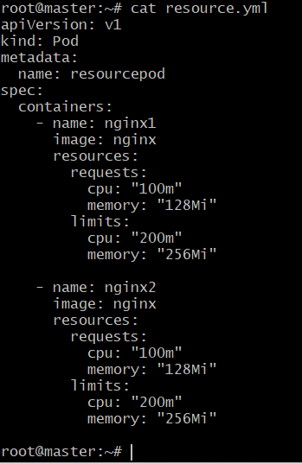

kubectl apply -f resources-pod.yml
kubectl describe pod resourcepod

